**//DESIGN CODE**

`timescale 1ns / 1ps

module elevator_controller (

input clk,

input rst,

input [3:0] req, // Requests for floors 0 to 3

input overweight, // 1 = too heavy, do not close doors

output reg [1:0] current_floor,

output reg door_open,

output reg moving

);

reg [1:0] state;

reg [1:0] next_floor;

// State encoding

parameter IDLE = 2'd0;

parameter CLOSE_DOOR = 2'd1;

parameter MOVE = 2'd2;

// Priority encoder to get requested floor

function [1:0] get_requested_floor;

input [3:0] req;

begin

if (req[3]) get_requested_floor = 2'd3;

else if (req[2]) get_requested_floor = 2'd2;

else if (req[1]) get_requested_floor = 2'd1;

else get_requested_floor = 2'd0;

end

endfunction

always @(posedge clk or posedge rst) begin

if (rst) begin

current_floor <= 2'd0;

door_open <= 1;

moving <= 0;

state <= IDLE;

next_floor <= 2'd0;

end else begin

case (state)

IDLE: begin

moving <= 0;

door_open <= 1;

if (!overweight && req != 0) begin

next_floor <= get_requested_floor(req);

if (next_floor != current_floor) begin

door_open <= 0;

state <= CLOSE_DOOR;

end

end

end

CLOSE_DOOR: begin

door_open <= 0;

moving <= 1;

state <= MOVE;

end

MOVE: begin

if (current_floor == next_floor) begin

moving <= 0;

door_open <= 1;

state <= IDLE;

end else begin

if (current_floor < next_floor)

current_floor <= current_floor + 1;

else if (current_floor > next_floor)

current_floor <= current_floor - 1;

end

end

endcase

end

end

endmodule

**//TEST BENCH**

`timescale 1ns / 1ps

module tb_elevator_controller;

reg clk;

reg rst;

reg [3:0] req;

reg overweight;

wire [1:0] current_floor;

wire door_open;

wire moving;

elevator_controller uut (

.clk(clk),

.rst(rst),

.req(req),

.overweight(overweight),

.current_floor(current_floor),

.door_open(door_open),

.moving(moving)

);

// Clock generator: 10ns period (5ns high, 5ns low)

always #5 clk = ~clk;

initial begin

$dumpfile("elevator.vcd");

$dumpvars(0, tb_elevator_controller);

clk = 0;

rst = 1;

req = 4'b0000;

overweight = 1; // Start in overweight state

#10 rst = 0;

// First person at ground requests 3rd floor (overweight is high)

#10 req = 4'b1000; // At 20ns

// At 40ns, overweight becomes 0

#20 overweight = 0; // At 40ns

// Keep request valid long enough for FSM to detect it

#20 req = 4'b0000; // Clear request at 60ns

// Wait for elevator to finish trip to 3rd floor

#100;

// Second person at 3rd floor requests to go to 1st floor

req = 4'b0010; // At 160ns

#20 req = 4'b0000; // Clear at 180ns

// Let elevator process the second trip

#100;

$finish;

end

initial begin

$monitor("Time = %0t | Floor = %d | Door = %b | Moving = %b | Overweight = %b | Req = %b",

$time, current_floor, door_open, moving, overweight, req);

end

endmodule

**//WAVEFORM**

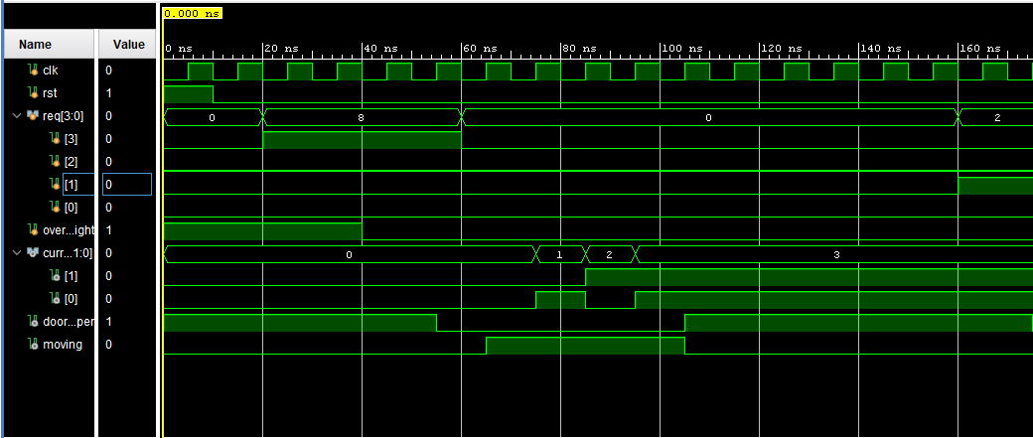

**//SCHEMATIC**

